**1.3.2 Structure Based Methods**

Systematic identification of structural domains by analyzing their 3-D structures has been going on for over 40 years now, the initial strides being made by Phillips(1970)[1], Ooi & Nishikawa(1973)[2]. Both of them constructed the Cα-Cα distance plots and identified domains by visually inspecting for triangular regions near the diagonal as shown in figure 1.1.

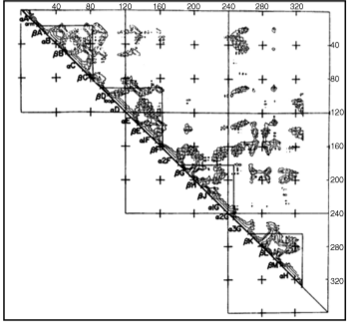

Figure 1.1: Cα-Cα distance plot of lactase dehydrogenase[3].

Rossman & Liljas(1974)[4] performed the first systematic algorithmic analysis of Cα-Cα distance plots and have been followed by myriads of algorithms trying to identify structural domains. Though differing in their implementations and peculiarities, almost all of these algorithms employ a common technique of decomposing the protein structure in a hierarchical fashion. On top of that, some of the methods work on the assumption that intra-domain residual contact density would be higher than that of inter-domain while others make use of the fact that a domain is a compact structure with a hydrophobic core. These are just some of the basic methods that are used and some of the prominent publications which have used these techniques are discussed below.

**?? where** What you have sent so far is an intro to seq and struc based appraoches, also list a few seq and struc based approaches and the basic principle behind those algorithms.

**References**

[1]: Phillips DC (1970): Past and present. Goodwin TW, editor. British Biochemistry. London: Academic Press, 11–28.

[2]: Ooi T, Nishikawa K, (1973). In: Bergmann A, Pullmann B, editors. Conformation of Biological Molecules and Polymers. New York: Academic Press, pp 173–187.

[3]: Veretnik S, Gu J, Wodak S: Identifying Structural Domains in Proteins. In In Genny Gu and Philip Bourne Structural Bioinformatics. Second edition. Wiley-Blackwell; 2009:485–513.

[4]: Rossman MG, Liljas A (1974): Letter: recognition of structural domains in globular proteins. J Mol Biol 85:177–181.